**Introduction**

Symbiotic relationships exist throughout the animal kingdom and even between animals and other kingdoms. What we know about these relationships can be categorized into parasitism, mutualism, and commensalism. These categories are clearly defined by how much the host or symbiont receives a benefit, harm, or no impact from the relationship. In nature, however, these relationships occur on a spectrum where the benefits and costs to the host and symbiont are not so clear. In some symbiotic relationships, the benefits and costs may vary depending on environmental conditions. These interactions complicate our understanding and ability to predict responses to environmental stressors. For example, we may know the thermal tolerances of our host and symbiont species individually, but how do they respond at points where their tolerances do not overlap? If we look more closely at these relationships, disentangle the impacts of environmental stress on either the host and the symbiont and connect the mechanisms that interact with each other, we can develop a much better understanding of the thresholds of benefit and cost in a symbiotic relationship.

*Anthopleura elegantissima* is an anemone found in the temperate Pacific Ocean which is frequently used as a model organism for investigating symbiotic relationships. Anemones are invertebrates in the phylum Cnidaria and class Anthozoa, along with corals. *A. elegantissima* is a small, abundant anemone species that can be found in the rocky intertidal zone from Alaska to Baja California, Mexico (Secord & Augustine, 2000). This anemone is easy to collect, care for, and manipulate in a laboratory environment due to its small size and mostly sessile life strategy. All these characteristics make *A. elegantissima* an ideal model organism for the study of cnidarian-algal symbioses.

*A. elegantissima* can form mutual symbiotic relationships with zooxanthellae (dinoflagellate symbionts) and zoochlorellae (green algal symbionts (Muscatine, 1971). Both symbionts contribute photosynthetic carbon to the anemone. In return, the anemone provides nutrients to the algal symbionts, and also provides a stable structure and access to sunlight (Peng et al., 2020). The two symbiont species have different ranges, due to variations in their temperature and light tolerance. Zooxanthellae are found throughout the range of *A. elegantissima*, while zoochlorellae are restricted to higher latitudes, north of 43°N (Secord & Augustine, 2000). At latitudes where both symbionts are present, zooxanthellae are more common in the high intertidal, while zoochlorellae are found in the low intertidal. It is also possible for the two symbiont types to be found within the same anemone in habitats where the two symbiont groups overlap.

Algal symbiosis in *A. elegantissima* is comparable to the more widely-studied relationship between tropical corals and their zooxanthellae symbionts; in fact these anemones are often used as a model organism to better understand symbiotic relationships in other cnidarians (Shaffer, 2018). Unlike most corals, however, which require algal symbionts to survive, *A. elegantissima* has a facultative relationship with its symbionts (Bedgood et al., 2020). This is because *A. elegantissima* lives in temperate, nutrient-rich waters, where prey is more abundant than in tropical ecosystems. The ability to live aposymbiotically, or without symbionts, leads to questions about the role of photosynthetic symbionts and the conditions under which these relationships are no longer mutually beneficial.

*A. elegantissima* can be aposymbiotic for a variety of reasons, including low light levels, low salinity, high temperature, and high UV exposure (Engebretson & Muller-Parker, 1999; Lesser, 1996; Weis & Levine, 1996). In the case of low light levels, symbiont loss occurs because the symbionts are unable to survive without light for photosynthesis. However, anemones may also lose some or all of their symbionts in conditions where the algae are able to survive, but the symbiotic relationship is no longer beneficial to the anemone. Zooxanthellae and zoochlorellae produce reactive oxygen species (ROS) as byproducts of photosynthesis; at high concentrations, these can damage the tissues of the anemone host ([Lesser](https://aslopubs.onlinelibrary.wiley.com/action/doSearch?ContribAuthorRaw=Lesser%2C+Michael+P), 1996). In this case, the anemone will actively regulate its symbiont population by expelling excess algal cells in a bolus of mucus, or by restricting nutrients that are required for algal growth (McCloskey et al., 1996).

There is a breadth of literature focusing on the thermal tolerances of zooxanthellae and zoochlorellae in their anemone host. These studies typically study long-term responses, from twenty-six days to six months to a moderate increase in temperature (Saunders & Muller-Parker, 1997; Tsuchida & Potts, 1994). These are relevant not only in understanding the current range and tolerances of *A. elegantissima* and their symbionts, but also in light of climate change as average air and sea surface temperatures increase and range shifts of intertidal organisms may occur. Zoochlorellae, the green algae, decrease in abundance in response to consecutive days of increased temperature (Saunders & Muller-Parker, 1997). This would be expected considering that anemones with zoochlorellae are restricted to northern latitudes and lower intertidal range (Secord & Augustine, 2000). Zoochlorellae also decreases in photosynthetic response at higher temperatures while zooxanthellae increases in photosynthetic response (Dimond et al., 2017). In summary, we know that moderate increases in temperature over a long term induce different responses in the two types of symbionts of *A. elegantissima* and may change in symbiont density, photosynthetic ability, or a combination for both.

Our understanding of the responses of *A. elegantissima* and its symbionts is limited when we consider extreme temperature events rather than long term, moderate increases in temperature. Marine heatwaves are increasing in frequency and duration over the last few decades, with as much as a 54% increase in the number of marine heatwave days over the last century. However, our understanding of how intertidal invertebrates respond to these events is limited. For our study, we will investigate several questions regarding the responses of *A. elegantissima* and its algal symbionts to marine heatwaves: will symbionts leave the host as a result of a marine heatwave? Will the two symbionts in *A. elegantissima* respond differently to heatwaves? Will heat stress have a negative impact on the anemone, algal symbionts, both, or neither?

We propose two alternative hypotheses that may occur. Our first hypothesis is that heat wave events will increase algal stress and decrease density of symbionts in *A. elegantissima*, because the algae will be negatively impacted by heat stress. If this hypothesis is true, we expect both photosynthetic efficiency and symbiont density to decrease, as the algae are exposed to temperatures beyond their physiological tolerance. Our second hypothesis is that heat wave events will cause *A. elegantissima* to expel its algal symbionts, due to an increase in the production of harmful byproducts of photosynthesis. If this is true, we would expect to see a decrease in symbiont density and no decrease in photosynthetic efficiency. Our study will measure photosynthetic efficiency as a proxy for algal symbiont stress, and base diameter of anemones as a proxy for host health. Algal symbiont density and mitotic index will also be measured to determine algal population size and growth rates within the host. Analyzing these measurements will allow us to investigate our hypotheses and contribute to broader knowledge on host-symbiont relationships and the impacts of marine heat waves.

**Methods**

*Anemone collection and care*

*A. elegantissima* were collected from the intertidal zone at Bluestone Point (48°49’03”N 125°09’57”W), Eagle Bay (Scott’s Bay) (48°50’03”N 125°08’48”W), and the Bamfield Marine Science Center (48°50’07”N 125°08’10”W). At each site, 15 individuals were collected from the mid-intertidal for a total of 45 specimens. Anemones were collected with their substrate if possible, or were removed from the substrate using a spatula or the rounded edge of a butterknife. Anemones with a base diameter less than 2 cm were excluded due to the difficulty of collecting tentacles from these anemones.

The anemones were acclimated to lab conditions for a period of two weeks prior to the start of the experiment. Each anemone was placed into a separate container to prevent interaction between individuals. Containers were perforated to allow for water flow and had rocks for settlement. They were then placed in a sea table with flowing seawater at approximately 11°C and a light schedule of 12 hours of light followed by 12 hours of darkness. The anemones were fed every four days using a diet of Artemia culture, and containers were cleaned after every second feeding.

*Experimental treatments*

After acclimation, 15 individuals were randomly assigned to each of three treatment groups: control (11°C), 25°C heatwave, and 30°C heatwave. Within each treatment, the anemones were grouped into five replicates, each of which received separate water flow. A diagram of the experimental setup is shown in Figure 1.

A simulated heatwave was carried out over a three-day period. During each day of the heatwave, the anemones were subjected to a 6-hour heat exposure event. The water flow to the anemones was turned off to simulate low tide. The sea table was plugged to create a “water bath” around the anemones, which was gradually warmed to the maximum heatwave temperature for each treatment using aquarium heaters and water pumps. A maximum water temperature was reached in approximately three hours, and this temperature was maintained for another three hours. After each heat wave, water flow was turned on to return the water temperature to 11°C.

*Photosynthetic efficiency*

The photosynthetic efficiency of the algal symbionts was quantified using pulse amplitude moderated (PAM) fluorometry. The anemones were removed from the water, covered for 20 minutes, and then the dark-adapted yield (Fv/Fm) was measured using a Junior-PAM fluorometer (Walz GmbH, Effeltrich, Germany). Measurements were taken at the top of the column of each anemone. If the anemone was open, it was disturbed so that it would close and the measurement could be taken. PAM fluorometry measurements were performed every three days during acclimation, twice per day during heatwave treatments (before and after each heatwave event), and once per day during recovery.

*Algal cell density and mitotic index*

Two to three tentacles were removed from each anemone using dissecting scissors one week before the heatwaves, on the first and last days of the three-day heatwave, and after five days of recovery. The tentacles were frozen at -20°C for analysis. The tentacles were then thawed, homogenized and diluted with seawater. Cell density and mitotic index were measured for each symbiont type (zooxanthellae and zoochlorellae) using a hemocytometer. The two symbiont types can be distinguished using a microscope; zooxanthellae are large and olive-brown in colour, while zoochlorellae are relatively small and bright green.

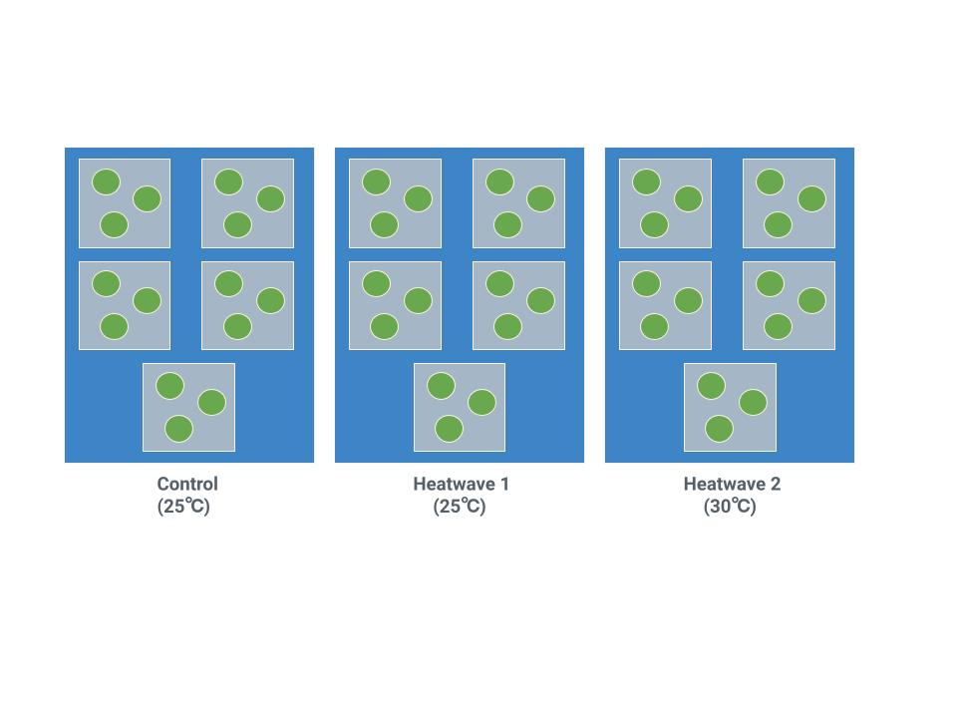

**Figure 1:** Diagram of experimental setup for heatwave treatments. Grey squares represent replicates with separate water flow, and green circles represent perforated containers holding individual anemones. During each heat exposure period, water surrounding the replicates (blue) was heated to the maximum heatwave temperature over a three hour period and sustained for an additional three hours before returning to ambient conditions.

**Bibliography**

Bedgood, S. A., Mastroni, S. E., & Bracken, M. E. S. (2020). Flexibility of nutritional strategies within a mutualism: Food availability affects algal symbiont productivity in two congeneric sea anemone species: Mutualism and nutritional flexibility. *Proceedings of the Royal Society B: Biological Sciences*, *287*(1940). https://doi.org/10.1098/rspb.2020.1860rspb20201860

Dimond, J. L., Orechovesky, S., Oppenheimer, J., Rodríguez-Ramos, J., & Bingham, B. L. (2017). Photophysiology and hydrogen peroxide generation of the dinoflagellate and chlorophyte symbionts of the sea anemone Anthopleura elegantissima. *Journal of Experimental Marine Biology and Ecology*, *489*, 43–47. https://doi.org/10.1016/j.jembe.2017.01.008

Engebretson, H. P., & Muller-Parker, G. (1999). Translocation of photosynthetic carbon from two algal symbionts to the sea anemone Anthopleura elegantissima. *Biological Bulletin*, *197*(1), 72–81. https://doi.org/10.2307/1542998

Lesser, M. P. (1996). Elevated temperatures and ultraviolet radiation cause oxidative stress and inhibit photosynthesis in symbiotic dinoflagellates. *Limnology and Oceanography*, *41*(2), 271–283. https://doi.org/10.4319/lo.1996.41.2.0271

McCloskey, L. R., Cove, T. G., & Verde, E. A. (1996). Symbiont expulsion from the anemone Anthopleura elegantissima (Brandt) (Cnidaria; Anthozoa). *Journal of Experimental Marine Biology and Ecology*, *195*(2), 173–186. https://doi.org/10.1016/0022-0981(95)00079-8

Muscatine, L. (1971). Experiments on green algae coexistent with zooxanthellae in sea anemones. *Pacific Science*, *25*(1950), 13–21. http://scholarspace.manoa.hawaii.edu/handle/10125/6104

Peng, S. E., Moret, A., Chang, C., Mayfield, A. B., Ren, Y. T., Chen, W. N. U., Giordano, M., & Chen, C. S. (2020). A shift away from mutualism under food-deprived conditions in an anemone-dinoflagellate association. *PeerJ*, *8*(1395), e9745. https://doi.org/10.7717/peerj.9745

Saunders, B. K., & Muller-Parker, G. (1997). The effects of temperature and light on two algal populations in the temperate sea anemone Anthopleura elegantissima (Brandt, 1835). *Journal of Experimental Marine Biology and Ecology*, *211*(2), 213–224. https://doi.org/10.1016/S0022-0981(96)02723-2

Secord, D., & Augustine, L. (2000). Biogeography and microhabitat variation in temperate algal-invertebrate symbioses: zooxanthellae and zoochlorellae in two Pacific intertidal sea anemones, Anthopleura elegantissima and A. xanthogrammica. *Invertebrate Biology*, *119*(2), 139–146.

Shaffer, L. (2018). *Chromosome visualization in a temperate anemone, Anthopleura elegantissima* (Issue June).

Tsuchida, C. B., & Potts, D. C. (1994). The effects of illumination, food and symbionts on growth of the sea anemone Anthopleura elegantissima (Brandt, 1835). II. Clonal growth. *Journal of Experimental Marine Biology and Ecology*, *183*(2), 243–258. https://doi.org/10.1016/0022-0981(94)90090-6

Weis, V. M., & Levine, R. P. (1996). Differential protein profiles reflect the different lifestyles of symbiotic and aposymbiotic Anthopleura elegantissima, a sea anemone from temperate waters. *Journal of Experimental Biology*, *199*(4), 883–892. https://doi.org/10.1242/jeb.199.4.883